**Tutorial Week 12**

**Data Administration**

***Following link is a good tutorial on common administration commands:*** [***https://www.oracletutorial.com/oracle-administration/***](https://www.oracletutorial.com/oracle-administration/)

**In this tutorial we will do only a subset of them.**

**PART 1: User Management**

In this part of the tutorial, you will understand how to create users, how create profiles to limit resource usage, how to create roles and how to assign privileges. You will be using following commands for this exercise.

**CREATE** PROFILE profile_name

**LIMIT** { resource_parameters | password_parameters};

**CREATE** **USER** username

**IDENTIFIED** **BY** **password**

[**DEFAULT** **TABLESPACE** **tablespace**]

[**QUOTA** {**size** | **UNLIMITED**} **ON** **tablespace**]

[PROFILE profile]

[**PASSWORD** **EXPIRE**]

[**ACCOUNT** {**LOCK** | **UNLOCK**}];

**CREATE** **ROLE** role_name

[**IDENTIFIED** **BY** **password**]

[**NOT** **IDENTIFIED**]

**GRANT** {system_privileges | object_privileges} **TO** role_name;

**GRANT** role_name **TO** another_role_name;

This part only contains some examples for granting privileges. More details of different types of privileges can be found here: <https://docs.oracle.com/database/121/TTSQL/privileges.htm#TTSQL345>

Some examples of granting privileges: <https://www.oracletutorial.com/oracle-administration/oracle-grant/>

In this part, you need to create a user account for Jenny Goodman, the new human resources department manager. There are also two new clerks in the human resources department, David Hamby and Rachel Pandya. All three must be able to log in to the oracle database and to read data from, and update records in, the HR.EMPLOYEES table. The manager also needs to be able to create new and remove employee records.

**Step 1. Profile Creation**

1. Create a profile named **CLERKPROFILE** that allows only 5 minutes idle time.

CREATE PROFILE CLERKPROFILE LIMIT

SESSIONS_PER_USER 2

CPU_PER_SESSION UNLIMITED

IDLE_TIME 5;

1. Create a profile named MANPROFILE that allows unlimited sessions and unlimited idle time.

**Step 2. Role Management**

Now, create the **HRCLERK** and **HRMANAGER** roles that will be used in the

next step. Here you have to think what permissions to be given to each role for each table. In this tutorial, we need to give permissions to clerks to read (i.e. Select operation) and update (Update operation) from EMPLOYEES tables. Similarly, you need to think in the context of manager. Following are the steps to implement these permissions.

1. Create the role named **HRCLERK**

Create role HRCLERK;

1. Grant object privileges to the role

Grant SELECT, UPDATE on HR.EMPLOYEES to HRCLERK;

Similarly, you can grant any other privileges including system privileges.

1. Create the role named **HRMANAGER** with **INSERT** and **DELETE** permissions on the **HR.EMPLOYEES** table. Grant the **HRCLERK** role to the **HRMANAGER** role.. [Note that you have used one role to be assigned to another role why?]

Grant HRCLERK to HRMANAGER;

**Step 3. User Management and Creation**

***Creating and Configuring Users***

In this practice, you create the following users and assign appropriate profiles and roles to

these users:

|  |  |  |
| --- | --- | --- |
| **Name** | **Username** | **Description** |
| David Hamby | DHAMBY | A new HR Clerk |
| Rachel Pandya | RPANDYA | A new HR Clerk |
| Jenny Goodman | JGOODMAN | A new HR Manager |

1. Create an account for David Hamby, a new HR clerk (i.e. assign HRCLERK and use CLERKPROFILE). You can use password as *‘abcd’.*

CREATE USER DHAMBY IDENTIFIED BY abcd PROFILE CLERKPROFILE;

GRANT HRCLERK to DHAMBY;

GRANT CREATE SESSION TO DHAMBY; --system privileges to allow connection with database

Without create session, you may get following error during connection:

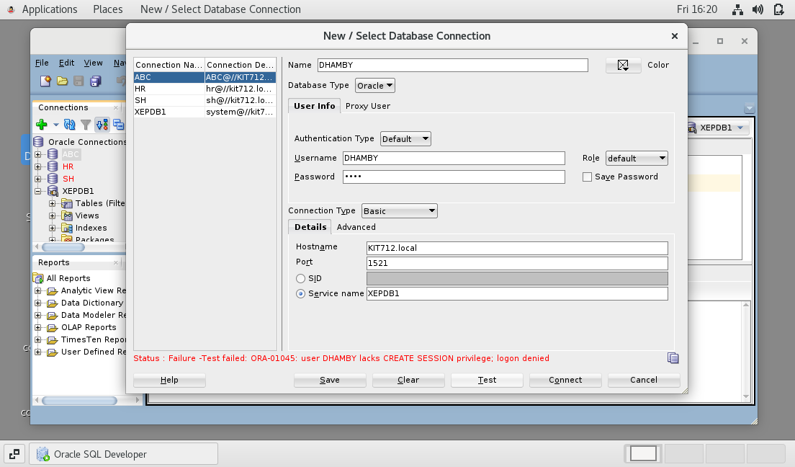



2) Create an account for Rachel Pandya, another new HR clerk. Repeat the steps shown above but with **RPANDYA** as the username and password *‘pqr’.*

3) Create an account for Jenny Goodman, the new HR manager. Repeat the steps above but use **JGOODMAN** as the username and select the **HRMANAGER** role instead of the **HRCLERK** role. Use password as *‘pwd’*; Also use MANPROFILE for profile of the user.

4) Test the new users in SQL Developer. Connect to the XEPDB1 database as the DHAMBY user. Select the row with **EMPLOYEE_ID=197** from the **HR.EMPLOYEES** table. Then attempt to delete it. (You should get the“insufficient privileges” error.)

To create a connection for DHAMBY user, you need to click first on **+** sign in your sql developer. And give information shown in following image. Password is same as the one you gave during creation of the user.

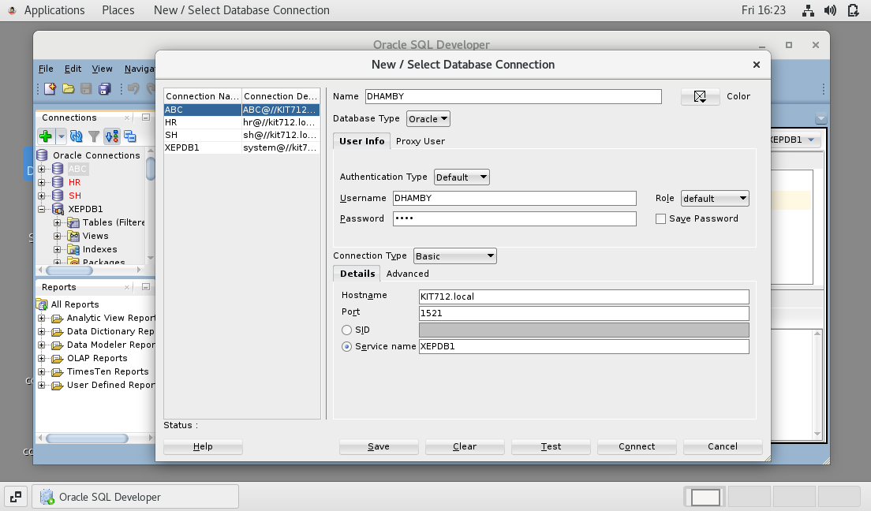



5) Repeat the test as the **JGOODMAN** user.

6) Leave DHAMBY connected for more than 5mins. HRPROFILE specifies that users whose sessions are inactive for more than 5 minutes will automatically be logged out. Verify that the user was automatically logged out by trying to select from the **HR.EMPLOYEES** table again.

Try the same test with JGOODMAN user. What do you find?

6) You can check whether users and roles are created successfully by using *dba_users, dba_tab_privs, dba_sys_privs* and *dba_roles* tables. Create SQL queries that check whether the above created users and roles are successfully created and privileges are successfully granted. For example,

select USERNAME, CREATED, PROFILE from dba_users where USERNAME='DHAMBY';

select * from dba_roles where ROLE like 'HRCLERK';

select GRANTOR, grantee,privilege, table_name from dba_tab_privs where TABLE_NAME='EMPLOYEES';

**Part 2. Data Dictionary**

**For this part of the tutorial, you need to login as system user in sqlplus or sqldeveloper. Password for ‘system’ user is ‘student’. This tutorial’s objective is to teach you basics of data dictionary. There are several data dictionary tables and views. You can get full list from here:** [***http://www.oracle.com/pls/tahiti/tahiti.catalog_views***](http://www.oracle.com/pls/tahiti/tahiti.catalog_views)***.***

To login as System user in SQL Developer, you need to first open SQL Developer using icon in your oracle labshare virtual machine. Then double click on XEPDB1.

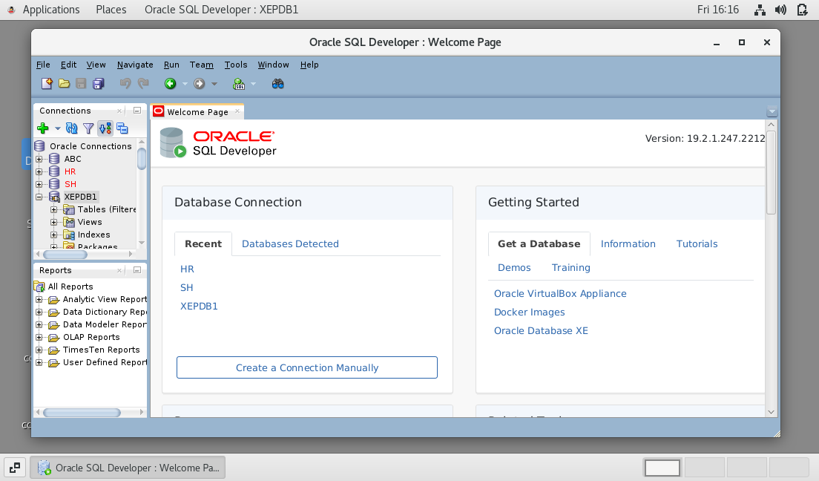



Q1. What information can you gather from the following query?Try this query after login as HR and then SH user/schema.

SELECT constraint_name, constraint_type, status, table_name FROM user_constraints

Q2. Find which user have access to the JOBS table. *Hint: 'dba_tab_privs' table contain this information*

Find out what are constraints on JOBS table; *Hint: dba_constraints table contains this information*

Q3. How can you find out whether the procedure 'ADD_JOB_HISTORY' did compile successfully? *Hint: the status of the procedure is then VALID. You can use 'DBA_OBJECTS' table for this*

Can you retrieve its source code from the dictionary? Hint: You can use 'dba_source' for this.

**Part 3. Managing Database Storage Structures**

*More information can be found in your lecture slides*

**Creating a Tablespace**

*Information about creating Tablespaces can be found at* <https://www.oracletutorial.com/oracle-administration/oracle-create-tablespace/>

Create a new, locally managed tablespace (LMT) called **INVENTORY** of size **5 MB with following information:**

* Use **INVENTORY** as the tablespace name,
* Extent Management is **Locally Managed**,
* Type is **Permanent**,
* Datafile size 5 MB

.

* Using following commands, execute following commands in your SQL Developer or SQLPLUS. Login as SYSTEM user:

set echo on

create table x (a char(1000)) tablespace inventory

/

insert into x values('a')

/

insert into x select * from x

/

insert into x select * from x

/

insert into x select * from x

/

insert into x select * from x

/

insert into x select * from x

/

insert into x select * from x

/

insert into x select * from x

/

insert into x select * from x

/

insert into x select * from x

/

insert into x select * from x

/

insert into x select * from x

/

insert into x select * from x

/

commit

/

quit

Do you see any error?. IF yes correct it by changing amount of space available for INVENTORY tablespace to 40MB. Rerun insert commands again.